LOT#_________________________________
Address ______________________________
Warranty Begins: _______________________

Congratulations on your recent home purchase. The decision to purchase a home is often one of the most important choices of a lifetime. I wanted to take a moment of your time to personally welcome you to the neighborhood. Owning a home is a something to be proud of and we at Bill Mace Homes take as much pride in the homes of our customers as we do our own. Please accept these recommendations and resources to make sure that your new home is a place of comfort and enjoyment for many years to come. Bill Mace Homes are crafted to last, using quality materials and attention to detail. Your Bill Mace Home is covered by our comprehensive warranty program and we know that routine maintenance and timely repairs will maintain your investment and preserve its beauty. We have included some helpful reminders and important answers to frequently asked questions to help you get settled!

New Home Orientation
During your new home orientation a warranty representative will walk through your new home with you and will explain how to care for your Bill Mace Home, and answer any questions you may have. This will give you the opportunity to confirm that all selections that you made are complete and you will receive warranties and instruction manuals for appliances and major systems. During this time it is important that we notate any items that are incomplete or need attention. All items marked for review will be addressed promptly, as minor issues come up over the course of your first year, your builder’s warranty is designed to address these items at your 11 month warranty walkthrough.

UTILITIES

The Electricity and Water are currently connected for your convenience. Please transfer the services within 48 hours to avoid an interruption in service.

Clarksville, TN Trash Pick-Up
Clarksville Gas & Water (931) 645-7400 Outlaw Disposal (931) 431-7944
Clarksville Dept. Electricity (931) 648-8151

Oak Grove, KY
Oak Grove Water (270) 439-5433
Pennyrile Electric (270) 886-2555

In Case of Emergency

In case of an emergency always dial 911.

If you have a plumbing or electrical emergency after hours please send a text to (615) 593-3023.

Please include your address and a detailed description of the problem.
MAINTENANCE
Many problems can be eliminated with a little troubleshooting. It is important to troubleshoot, to avoid service fees from technicians.

PLUMBING Please troubleshoot using only the following methods. Do not attempt to fix or make any changes to your plumbing without a Licensed Plumber, this is dangerous to you and your home and may void your warranty.

When you move in, place a paper towel under all sinks to check for any water leaks

- If you suspect a water leak: Turn off water supply to the area. Abstain from using that area until a plumber has evaluated the issue. Submit your warranty request in writing to warranty@billmacehomes.com and make sure to provide all information requested. Warranty requests may not be made via phone. If the problem is a manufacturer or workmanship defect the plumbers will not charge you a service fee. Take time upon move-in to locate your shut off valves for the Main supply as well as individual fixtures. Main shut offs are located near water heater.
- Clogged Drains Clogged drains can be avoided by taking great care in what you put down drains especially the kitchen sink drain; the most used and most clogged drain in the house. Clogged drains are not covered by your warranty.

ELECTRICAL Please troubleshoot using only the following methods. Do not attempt to fix or change any electrical wiring without a Licensed Electrician, this is dangerous to you and your home and may void your warranty.

- If you have one or more electrical outlets or a system that is not receiving power; Including the Garage door opener. Unplug lamps and appliances from dead outlets to eliminate the possibility that a short or overload from one of them is causing the problem. Locate the circuit breaker box and check for flipped circuit breakers. Tripped circuit breakers aren’t always apparent. If you don’t see a tripped breaker, firmly press every breaker to the “off” position and back on. If the tripped breaker won’t reset without tripping again, there could be a potentially dangerous short circuit or ground fault condition. Switch the breaker to the off position and call the office (931)-551-7751 and we will send an electrician. If the circuit breakers are working properly, next check the GFCI.
- GFCI (short for “ground fault circuit interrupter”) outlets, those unusual outlets with the test and reset buttons, are required in areas of the house where shock hazards are greatest. They protect against deadly electrical shocks by sensing leaks in the electrical current and immediately tripping to shut off the power. But it’s easy to overlook a tripped GFCI as the source of a dead outlet problem. Look for GFCIs in bathrooms, kitchens, basements, garages, and on the home’s exterior. Test and reset every GFCI you find. If the GFCI “reset” button doesn’t pop out when you press the “test” button, there may be no power to the GFCI or you may have a bad GFCI. On the other hand, if the “reset” button trips again every time you press it, there may be a dangerous current leak somewhere on the circuit. Call the office (931) 551-7751 and we will send an electrician.
Test your GFCI outlets monthly to make sure they are working properly.
- If you have a light fixture that is not working, always replace the bulb before submitting a warranty claim. Bad bulbs are not covered by your warranty. Do not replace bulbs with anything over 60watts

HVAC You must register for your warranty directly through Mainstream Heating & Cooling within 60 days of your home purchase. (931) 647-9610

Call Mainstream Heating and Cooling within 60 days of your new home purchase to sign up for a registered 10 year limited parts and 2 year labor warranty at no charge to you.

- If you experience problems with your HVAC
Mainstream Heating & Cooling
1539 Ashland City Rd. Suite A
Clarksville, TN 37042 (931) 647-9610

Change your filter monthly when you pay your electric bill. 90 days filters can build with dust and use extra energy, and cause stress to your HVAC system.

APPLIANCES You must register for your warranty directly through appliance manufacturer within 30 days of your home purchase. Appliance cards are provided to you by the manufacturer.

- If you experience problems with your appliances please contact the manufacturer directly.
Note: You must register each appliance individually.

- Clean stove top with Ceramabrite, it can be purchased at any Home Improvement store. Empty the first batch of ice from fridge and discard, as the line has not been circulated. Of you leave for a long period of time, when you return add a cup of water to your dishwasher. The water will evaporate in the pump and burn itself up if not properly primed. Use only Stainless Steel Cleaner, never use Windex on appliances, it will cause them to rust.

SMOKE DETECTORS
Smoke detectors are electric with a battery backup. The batteries need to be changed every 6 months. A good way to remember is to change them at daylight saving time. Check alarms once a month. When one alarm signals, it signals the other alarms. . If a smoke alarm is chirping consistently the smoke alarm’s battery may need to be replaced. An alarm will chirp every 30 to 60 seconds for a minimum of seven days.

WINDOWS
Always raise the window above the bottom ledge, and they tip out for easy cleaning.

WATER SAVER TOILETS
If you twist the knob counter on top of the floater, it lowers the water level. Clockwise raises the water level.

WATER HEATER
At least every 18 months, turn off the breaker to the water heater. Attach a garden hose to the bottom spout and drain it. After draining it, flush it. Then fill the water heater up, go inside and open the hot water spigot to get the air out of the line. Turn the breaker back on. This is to prevent calcium build up on the bottom element costing higher energy to heat.
OUTSIDE HOSE BIBS

Never leave a garden hose connected in the winter. It can result in busted pipes, which are not covered by your warranty.

DECK
Do not seal or stain your deck, until it turns white. We use pressure treated lumber and it can deteriorate from the inside out, if you do it too soon.
GARBAGE DISPOSAL
Don’t put anything in the disposal that you wouldn’t eat. Chicken bones, potato or onion peels, and popcorn kennels wreak havoc on disposals. Every 6 months run ice through the disposal to sharpen the blades.

GARAGE DOORS
If the ground fault is tripped the garage doors will not operate. If the two sensors at the bottom of the door are misaligned, they will not work properly. If you call for a serviceman to come they will charge you for troubleshooting.
LANDSCAPING

Landscaping is not a warrantable item and we want you to get the most out of your new lawn.
To develop a beautiful lawn, please consider the following recommendations.

- New lawns need plenty of water. To establish your new lawn you must water every day. Do this as thoroughly as possible, without creating washouts or erosion. It is best to water very early in the morning so that the water penetrates the soils, rather than during the heat of the day.
- Seasonal rain will cause some washouts and settlements within your new lawn. We will return at your 11 month warranty walkthrough, and we will repair washouts and settlements within 10’ of your home. Since there are many factors beyond our control which will affect the establishment of your new lawn, you will be responsible for lawn establishment. We can only provide you with the proper grade and swales. You must maintain these. Be sure to repair any washouts as soon as possible so they do not cause further erosion.
- It is inevitable that bare spots will occur in any lawn; this is not a warrantable item. Over seeding of your new lawn with an appropriate seed mix is strongly recommended during the first spring and fall planting seasons. Over seeding is more effective than fertilizing and aeration. Over Seeding is a homeowner maintenance item.
- It takes 1-3 years to establish a lawn, it is critical to maintain a regular lawn care program. Allow your lawn to become fully established before using weed control products.
- Fertilize your lawn, water your lawn and keep it cut to 3-4” for optimal results.
- During summer do not cut your lawn too short. Moisture will remain in soil longer if the grass is higher and your lawn will be healthier.
- The establishment of adjoining lawns will require minor work on the property line to properly establish the grading area. This will allow us to better grade and drain neighboring properties, as well as your own. Please be patient, we will repair anything we disturb.

Builder’s Warranty

Frequently Asked Questions

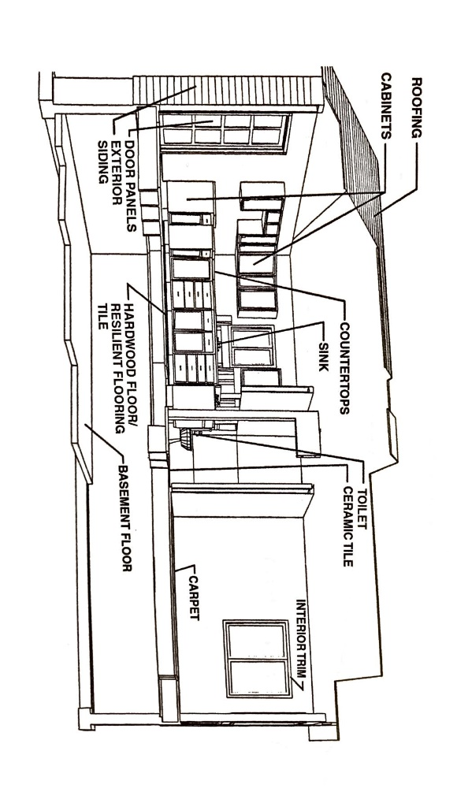
What is the Builder’s warranty?
Our Builder’s warranty is the guarantee that you are covered from any workmanship flaws during the first year in your new home. The One Year Workmanship Coverage includes all manufacturer’s defects and workmanship defects illustrated in the diagram below. This coverage does not extend to wear and tear and cosmetic items.

What items are not covered?
Warranty excludes any wear and tear due to excessive moisture and liquid exposure, improper care and maintenance, negligence or abuse including but not limited to damage caused by people & pets. Appliances and HVAC are covered directly by manufacturer warranties and must be registered within 30 days of your home purchase. Instructions are provided for you.
- Landscaping, Grading & Swales
- Decks & Fences
- Concrete
- Other Exclusions include deterioration of construction materials within expected levels, including warpage or shrinkage within industry standards, or changes due to weather conditions, natural disasters, soil movement or settling

When does coverage begin?

Coverage begins the date of your walkthrough, not the date of closing For example, if you have requested an early occupancy, or taken possession prior to closing the builder's warranty begins at that time.

How do I request a service call?
If you have problems that arise that cannot wait such as a water leak or repair that needs immediate attention, refer to our section on troubleshooting. If troubleshooting does not eliminate the issue submit the provided warranty request form to warranty@billmacehomes.com.

Do I have to be home during the repair?

We understand that you cannot always be present for repair appointments. We don’t require anyone to be present for minor exterior repairs, just make sure that all animals are secured and if the area that needs attention is inside the fence, that the contractors have access to the gate. We ask that someone over 18 be present for any interior repairs. Sub-contractors cannot enter your home without someone acting as a representative on your behalf that can sign for the completion of requested repairs.

Is there a service fee or deductible for each visit?

There is never a service fee from the builder. We ask that as minor issues come up over the course of the first year in your new home (nails showing, minor drywall cracks from settling, etc.) that you note them on your 11 month Service request Form and simply send that form to warranty@billmacehomes.com approx.. 11 months after you move in. a Warranty representative will contact you to schedule a time to review the items covered by your warranty and schedule any necessary repairs. Please be sure to familiarize yourself with Homeowner maintenance procedures such as replacing HVAC filters or periodically flushing the sediment build-up through your water heater. Failure to do these basic things will cause damage to your systems. If a system has not been maintained, Bill Mace Homes will not be responsible for the repair.
If you have problems that arise that cannot wait (plumbing, electrical, etc.) You can submit a warranty request in writing, and we will send a technician promptly. If the repairs are necessary due to manufacturer defect, there will be no charge for the service call.
Please Note: You must submit the warranty claim through your warranty coordinator or you may be subject to technician’s service fees and/or materials.
Bill Mace Homes does not reimburse for service fees/ materials that are not ordered by your coordinator. We will work hard to try and resolve your requests promptly and efficiently. There may be circumstances where repairs may have to be rescheduled due to weather or other variables. Bill Mace Homes and their subcontractors will not be held liable for any lost wages or lodging expenses during repair appointments.

Warranty Claim Request

Please fill out all required information. Include Photos for warranty claims. Form must be submitted in writing for approval. Warranty claims cannot be processed via phone. All request will be reviewed within 48 hours of receipt.
*Homeowner’s Name _______________________________* Phone#____________________________
Email ____________________________________________ Phone # ____________________________
*Lot # _______________________________* Subdivision _____________________________________
*Physical Address ______________________________________________________________________
* Closing Date (da/mo/year) _______________________
Briefly describe each item separately. (Please specify location; Master Bath, Kitchen,)
1._______________________________________________________________________________________________________________________________________________________________________________________________________________ Location: ______________________________________
When did you notice this issue? ___________________________________________________________
What/ if any / troubleshooting have you performed? __________________________________________

What days of the week are best to schedule appointments? ____________________________________
No weekend appointments.

Do you prefer morning or afternoon appointments? (9-12) (12-4)

Please provide photos with claims.

Submit Form to:

Email: Warranty@BillMaceHomes.com or Mail USPS.

11-Month Warranty Request

Please fill out all required information. Include Photos for each item. All items Must be marked with blue tape.
*Homeowner’s Name _______________________________* Phone#____________________________
Email ____________________________________________ Phone # ____________________________
*Lot # _______________________________* Subdivision _____________________________________
*Physical Address ______________________________________________________________________
* Closing Date (da/mo/year) _______________________
Briefly describe each item separately. (Please specify location; Master Bath, Kitchen,)
1._________________________________________________ Location__________________________
2._________________________________________________ Location__________________________
3._________________________________________________ Location__________________________
4._________________________________________________ Location__________________________
5._________________________________________________ Location__________________________
6._________________________________________________ Location__________________________
7._________________________________________________ Location__________________________
8._________________________________________________ Location__________________________
9._________________________________________________ Location__________________________
10._________________________________________________ Location__________________________

What days of the week are best to schedule appointments? ____________________________________
No weekend appointments.
Do you prefer morning or afternoon appointments? (9-12) (12-4)

Please provide photos with claims. Submit Form to: Email: Warranty@BillMaceHomes.com or Mail USPS.

Future Projects!

PREFERRED VENDORS
  - We have created a list of preferred vendors that we recommend for future projects. Please note that Bill Mace Homes cannot be held liable for any unsatisfactory services.

Bluegrass Plumbing 270-886-3116 Closet Specialist 931-206-3233

Big Hay Flooring 931-648-3571 Backsplash Specialist 904-226-4890

Warren Electric 931-624-3273 Pike Painting 931-449-9957

Decks & Fences 931-624-7788 Big D Concrete 423-557-2147

Wallace Building Supply 931-232-7187 www.wallacebuilding.net

Alpha Fireplaces for Less 931-801-0409 www.Alphafireplacesforless.com

The Garden Place 931-648-7878 www.clarksvillesgardenplace.com

Cutsinger’s Carpet Cleaning 931-221-9966 www.Cutsingerscarpetcleaning.com

Jodi’s Cabinets 931-542-9815 www.jodiscabinetsales.com

Have someone you think should be added to this list? Let us know at Warranty@billmacehomes.com!

